Wendy Bronson
Module 9.2 API’s
07/18/2026

Task 1: API Tutorial
Screenshot 1: Connection Test

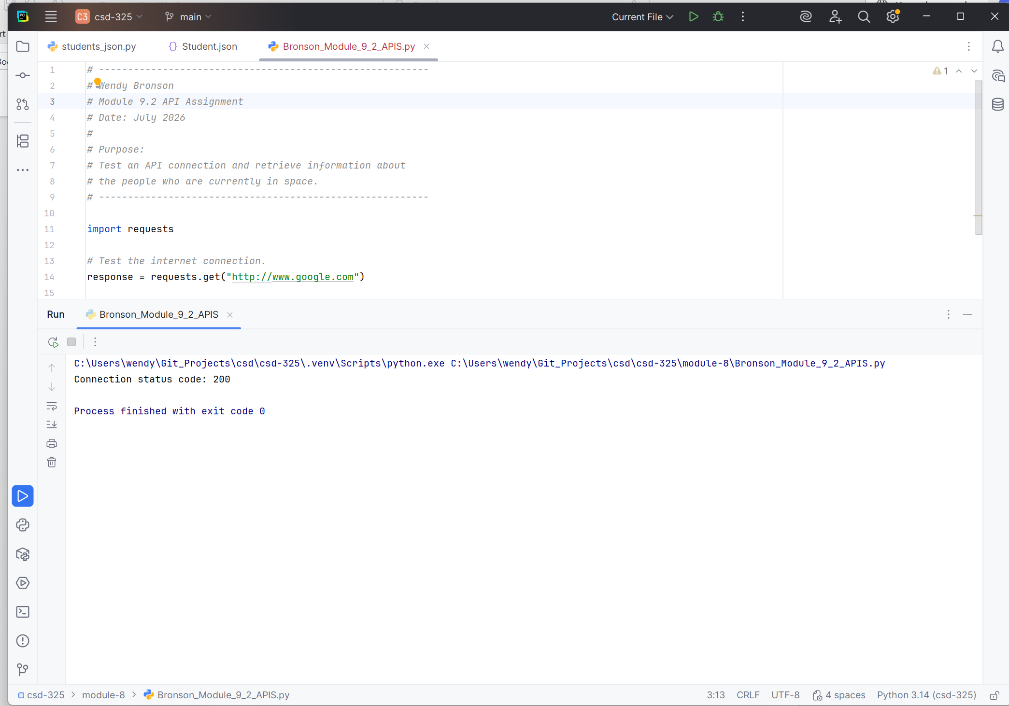
Screenshot 2: Current Astronaut API Results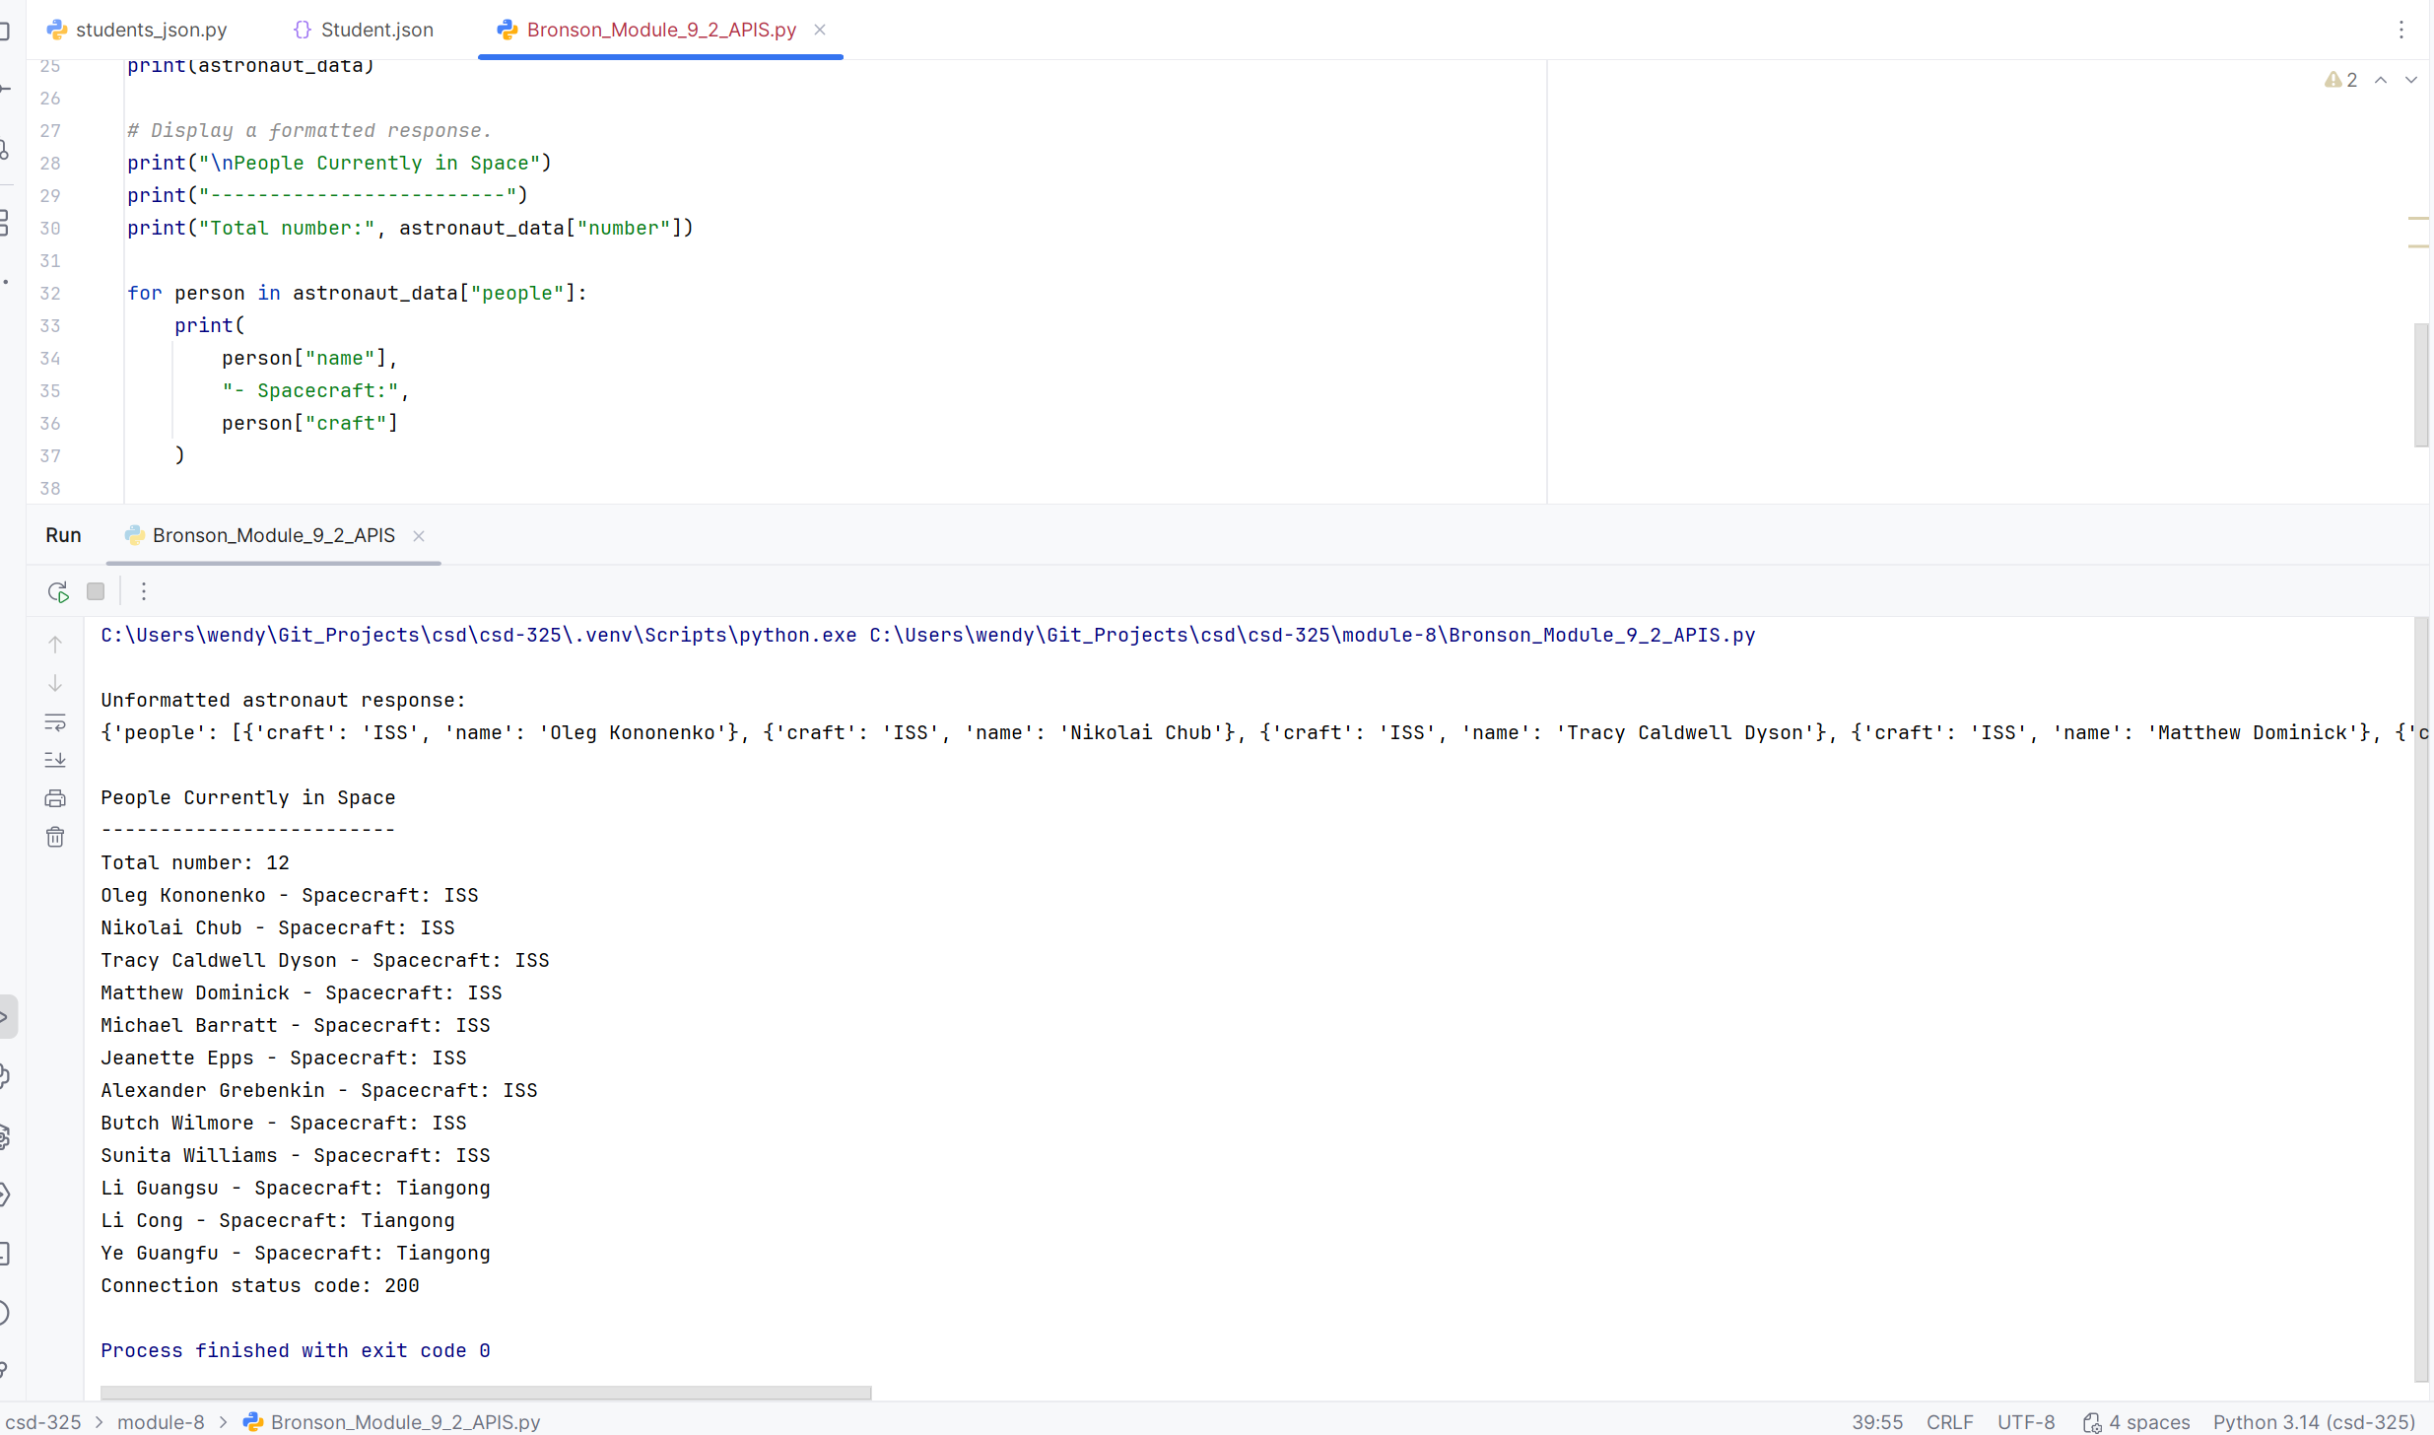
Task 2: API of Choice
Screenshot 3: API of Ice and Fire Results:
